**Aqua-Trail: IOT Based Smart Water Bottle**

Vanshaj Barnwal,

B-Tech Student,

*Department of Network and Communications,*

*School of Computing, SRM Institute of Science and*

*Technology, Kattankulathur, Tamil Nadu,*

*India.*

[vb4416@srmist.edu.in](mailto:vb4416@srmist.edu.in)

Vinay Poddar, B-Tech Student,

*Department of Network and Communications,*

*School of Computing, SRM Institute of Science and*

*Technology, Kattankulathur, Tamil Nadu,*

*India.*

[*vp6866@srmist.edu.in*](mailto:vp6866@srmist.edu.in)

Mrs. D. Saisanthiya, Assistant professor,

*Department of Network and Communications,*

*School of Computing, SRM Institute of Science and*

*Technology, Kattankulathur, Tamil Nadu,*

*India.*

[saisantd@srmist.edu.in](mailto:saisantd@srmist.edu.in)

***Abstract* - The Smart Water Bottle is a cutting-edge technical solution created to address the ever expanding issue of staying properly hydrated in our daily lives. Dehydration is a serious health problem that can have a range of negative repercussions, including poor physical and cognitive function. A smart water bottle is a type of water bottle that uses sensors and technology to track fluid intake, monitor activity, and provide insights into hydration levels. Smart water bottles can typically connect to smartphones or other devices via Bluetooth or Wi-Fi, allowing users to track their progress towards hydration goals, receive reminders to drink water, and view data on their hydration habits. To measure and optimize users' hydration patterns, this smart water bottle makes use of cutting-edge sensor technology, networking, and data analysis. Numerous sensors, including accelerometers, temperature sensors, and fluid level sensors, are included in this smart water bottle. Together, these sensors keep track of ambient conditions and water intake. The information is then transferred to a special smartphone app through Bluetooth or Wi-Fi so that users can quickly access and understand their current level of hydration. To promote healthier drinking pratices, the app offers insights into daily water intake targets, personalized recommendations, and historical data. The Smart Water Bottle may alter messages and reminders based on the user's activity levels, the weather in the area, and individual preferences in addition to monitoring water intake. Additionally, it provides the choice of user-customizable hydration goals, allowing users to adjust the suggested water consumption to meet their own requirements. By encouraging proper hydration, assisting in the prevention of health problems associated with dehydration, and minimizing single-use plastic bottle waste, this innovation has the potential to significantly improve public health. The Smart Water Bottle is a promising option for a healthier and more sustainable future since it combines technology with a necessary component of daily living.**

***Keywords - Hydration; Wi-Fi; Sensor; Smart Water Bottle.***

1. INTRODUCTION

We are aware that everything in today's world is connected to the Internet, making life more simpler. IOT, or the Internet of Things, is one of the technologies that has grown quickly. It enables us to create web and mobile connected application, such as those for smart homes, healthcare, transportation, and other areas. Dehydration is a common yet frequently ignored health issue. Dehydration, which affects people of all ages and socioeconomic levels, is a serious global health issue, according to the World Health Organisation (WHO). While extreme forms of dehydration, such as heatstroke or extended physical exertion, are frequently associated with dehydration, mild to moderate dehydration is more prevalent and can have subtle but detrimental impacts on our health and daily life.

Water helps break down food particles for absorption and is a crucial ingredient of digestive juices. Maintaining adequate water facilitates the easy passage of food through the digestive system, avoiding constipation and enhancing general digestive well-being. Moreover, water is necessary for the body's metabolic functions, which include turning food into energy. It aids in the body's ability to metabolize fat that has been stored and makes it easier for waste to be expelled through perspiration and urine. Essential for the healthy operation of organs like the kidneys, which remove waste from the blood and excrete it as urine, water is needed. Kidney stones and impaired kidney function can result from inadequate water intake, which may pose major health risks.

Water is an essential component of blood in the circulatory system because it helps carry nutrients and oxygen to cells while eliminating waste. Sustaining appropriate levels of water is essential for promoting heart health and blood circulation.

Beyond just feeling thirsty, dehydration has significantly more negative effects. Dehydration, even minor dehydration, can affect physical and mental performance and increase the chance of developing a number of illnesses. Dehydration is frequently characterized by headaches, weariness, dry skin, and black urine. Chronic dehydration can eventually lead to more serious medical issues like kidney stones and urinary tract infections. For vulnerable populations, such as the elderly, athletes and small children, inadequate hydration is particularly important. People become less able to recognize thirst as they become older, which increases their risk of dehydration. Children, on the other hand, cannot completely comprehend the significance of adequate hydration and frequently require reminders to do so. Severe dehydration can, in some circumstances, be fatal.

Maintaining sufficient hydration might be difficult in today's fast-paced, technologically-driven society. Modern life's distractions, crammed work schedules, and excessive screen time can cause us to become unaware of how much water we need. Additionally, cities frequently have easy access to sugary drinks and caffeinated beverages, which can dehydrate people and encourage bad hydration practices. In addition to these issues, the way we engage with the outside world has altered as a result of our always-connected digital existence, making it simpler to put our health second to our virtual interests.

We can aid those who need a way to keep track of their water use by developing smart water bottles that are IOT-enabled. The usage of sensors, Arduino, a WiFi module, mobile applications, etc. is part of this technology. The first step of the approach is to use an ultrasonic sensor to determine how much water the user has consumed. The sensor collects data, which is then transmitted via the WiFi Module to the cloud. To track water consumption at any time, data is regularly transferred to the cloud. The mobile application then retrieves this data from the cloud so that the user may check their state of hydration.

The Smart Water Bottle is a potentially game-changing answer to the problems associated with staying hydrated in today's society. Its effects are felt on a number of levels:

The Smart Water Bottle can help prevent a variety of dehydration-related health problems, lessening the strain on healthcare systems, and enhancing general wellbeing by encouraging proper hydration.

The Smart Water Bottle can help athletes and energetic people maintain optimum performance by making real-time hydration recommendations depending on their levels of physical activity. The consumption of single-use plastic bottles can be considerably decreased by promoting the use of reusable water bottles, resulting in a more sustainable and environmentally friendly future.

The Smart Water Bottle raises people's consciousness of the value of healthy hydration. Users may choose their fluid intake wisely thanks to the app's reminders and data tracking, which eventually leads to better lives.

The Smart Water Bottle can be a lifeline for people in need, including the elderly and little ones, making sure they get the hydration they require even when they aren't conscious of their own thirst. Researchers and healthcare professionals can benefit from the quantity of data gathered by the Smart Water Bottle app in order to better understand hydration patterns and create strategies to address concerns connected to dehydration.

The purpose of Aquatrail is to measure the amount of water consumed, but it also alerts the user appropriately through a mobile application if their water consumption is below average. Thus, as it enables user interaction with the Smart Water Bottle, the role of mobile applications is just as crucial as the roles of other equipment.

Water is essential to human life and plays a crucial role in preserving health, energy, and general well-being. The fact that it is involved in almost every biological function demonstrates its diverse significance. Recognizing the importance of water and staying well hydrated is essential to a happy and healthy life for humans.

1. RELATED STUDIES

A few of the problems we ran into when developing the smart water bottle were with its design and system architecture, components, technology used, functioning, and impact on hydration habits. The publications that we consulted when creating the smart water bottle are really helpful to us. Each article plays a crucial function because it has greatly aided us in keeping track of water level, reminding us about the technology used for alerting by giving reminders, etc.

[2]Managing the data and alerting the user with reminders is essential aspect which we considered which working on the project. This paper focuses on a system that only provides the user with the statistics of their daily amount of water intake and daily average, but also nudges the user with reminders on drinking water every 2 hours. Thus, this product provides the user with a meticulous way of managing their water intake which one tends to forget[2].

[3]This paper proposes a system that develops a model based on fuzzy algorithm. Smart water bottle system provides the user with the prediction of their daily amount of water intake. The results provided are also in accordance with the rules that have been made, namely low, medium and high. The fuzzy algorithm used in the IOT platform is less responsive or still has a long enough delay, and can display more accurate measurements.[3]

[4] An overview of IoT solutions in the developing market was provided in this article. In the near future, the importance of IOT will simplify our lives in a variety of ways, including the environmental requirements and health department. The market solutions were categorized into five major groups in this paper: smart wearables, smart homes, smart cities, smart environments, and smart enterprises. Wearable technology, such as smart watches, informs us about Internet of Things items that we can utilize on a regular basis. Numerous IoT-related solutions, such as smart meters, gas detection, and smart security, are also included in "smart homes." Smart cities have characteristics like intelligent traffic management, where cars use Internet of Things software to track traffic as they go forward. There are also IoT solutions that have been proposed, designed, developed, and brought to market by industrial organizations[4].

[5]This paper presented an automated liquid intake tracking solution, which does not require recurrent input from user. It uses accelerometer data from a smartwatch to detect drinking gesture of user and a load sensor-equipped container to determine the amount of liquid consumed in each sip[5].

[6]This paper proposes a design and implements a fluid intake monitoring system that fulfills many requirements for fluid intake monitoring: it is based on an easily deployable, simple sensor setup, works across different drinking containers, and has the ability to provide information on container type and fluid level[6].

[7]This paper proposes a design which is very encouraging. It is aimed at developing a highly efficacious and practical water intake management planner that provides both diagnosis and prescription based on user water intake rather than simply providing suggestions and confirming ingestion. Therefore, if this solution is introduced, enabling users to develop and manage proper water intake habits, it will receive attention from members of the new senior generation who are interested in health. It will also open a new chapter in research on water intake[7].

[8]This paper developed a system that will reduce human intervention in water management which is adaptable in both the urban and rural scenarios incorporating the sustainability factor. It come up with a viable system that automates the functions as well as increases the sustenance of the source in the long run[8].

[1]This paper proposed a model of smart bottle architecture for hydration reminder to remind the humans to intake the sufficient water on time to keep the body stable is successfully implemented. In todays life people often forget to drink ample amount of water, proper reminders at regular intervals will ensure that they are hydrated properly. This project not only tracks how much amount of water the user is drinking, but it also indicates if there is a long gap of water consumption, when there is long time gap it alert the user by sending a messages to the smart phone.[1]

1. METHODOLOGY

Smart water bottles track and promote hydration through a variety of hardware components and techniques. A architecture diagram (refer figure 3.1) must be used to design a Smart Water Bottle that is trustworthy and efficient. To monitor and optimize hydration, the development process integrates a variety of technologies, sensors, and software elements. The following is a suggested process for creating a smart water bottle:

Figure 3.1 Architecture Diagram

**Planning a project and gathering requirements:**

Establish the project's goals, target audience, and scope. Describe the precise attributes and capabilities that the Smart Water Bottle will have, establish precise performance and usability standards, Set a budget and timeframe for the project. Design the project with the help of block diagram (refer figure 3.2) to ensure the right workflow.

Figure 3.2 Block Diagram

**Selection and Integration of Sensors:**

Choose the right sensors (refer figure 3.3) to keep an eye on the environment and water intake. These could consist of ultrasonic sensor, wifi-module, jumper wires, water bottle. To extend the battery life of the gadget, make certain that the selected sensors are precise, dependable, and energy-efficient.

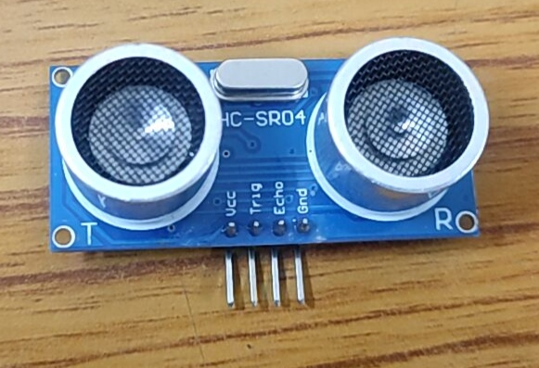

Figure 3.3 Ultrasonic Sensor

**Connection Methods:**

Choose the connectivity type that will be used to send data to a smartphone app. Wi-Fi and Bluetooth Low Energy (BLE) are popular choices. In this project we have used the Wi-Fi module for connectivity. The Wi-Fi module used in this project is ESP8266( refer figure 3.4). Create the hardware elements required for creating a dependable connection with the application.

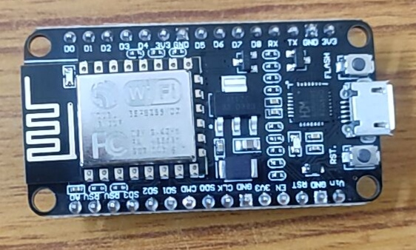

Figure 3.4 ESP8266 Module

**Designing and prototyping hardware**

Create the Smart Water Bottle's physical structure while taking into account elements like size, shape, and material (such as BPA-free plastics, stainless steel, or glass). To verify the integration of sensors and connectivity components, make a working prototype. In the prototype (refer figure 3.5) we have kept the ultrasonic sensor in the cap of the water bottle to track the level of water. Make sure the bottle can be easily refilled, maintained, and cleaned.

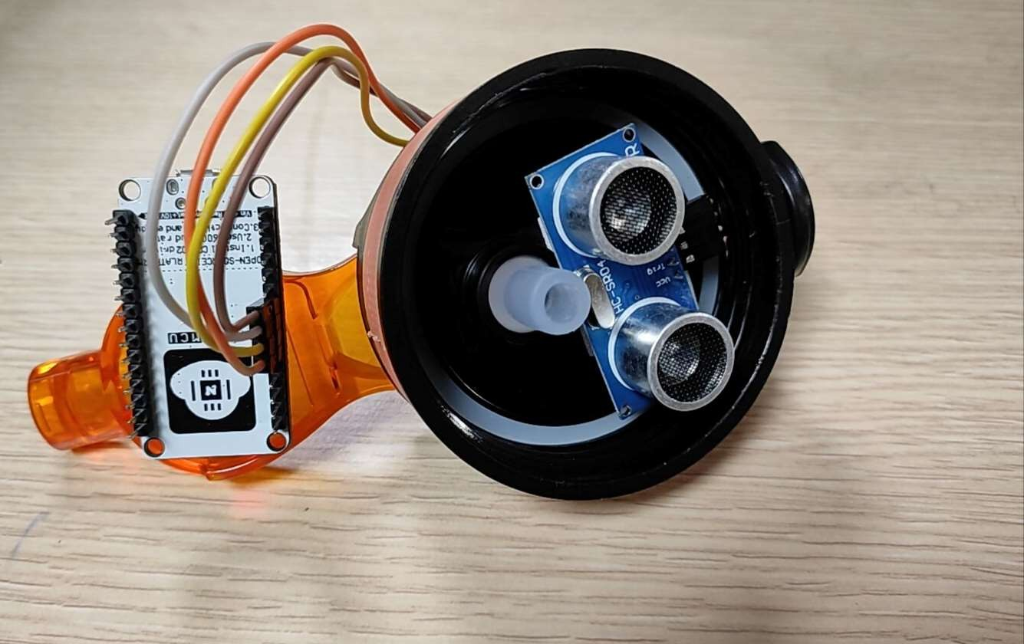

Figure 3.5 Prototype

**Create an application:**

Create an Android compatible user-friendly smartphone app (refer figure 3.6). To receive and interpret real-time data, integrate the app with the sensors and networking capabilities of the Smart Water Bottle. Include tools for establishing hydration goals, making tailored suggestions, and tracking historical data. Adaptive reminders should be implemented based on user activity levels, the weather, and personal preferences. Give privacy controls and data sharing options while securely storing user data.

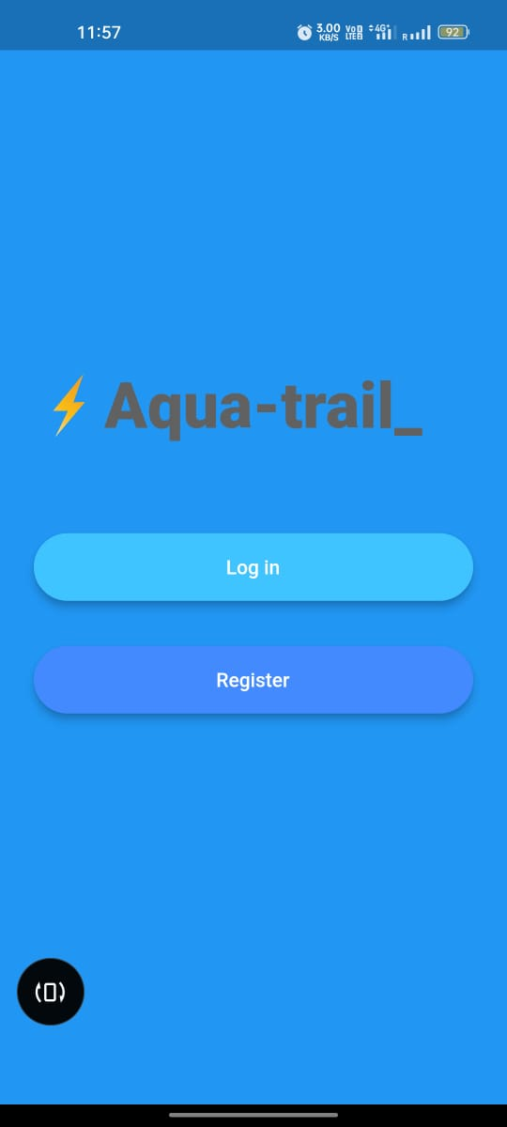

Figure 3.6 Mobile Application

**Stages in the Proposed Method:**

**Input:** Arduino and sensors (hc-sr04) are used in the input stage to collect data. The ultrasonic sensor has four pins – trigpin, echopin, Vcc, GND. The trigpin is connected to the D5 pin in the Wi-Fi module, echopin is connected to the D6 pin in the Wi-Fi module, Vcc is connected to the 3V3 pin, and the GND is connected to the GND pin in the Wi-Fi module.

**Processing:** Following data collection, the data must be transmitted to the cloud (using the WiFi-Module ESP8266) via the MQTT protocol utilizing publish and subscribe messaging transport. Once the data has been received by the cloud Firebase. The Firebase is used as it will also help in the authentication process when it needs to save the credentials of the individual in the cloud.

**Output:** A mobile application is used to establish communication between smart water bottle and the user. The user needs to register and sign-in in the application, then the amount of water which will be consumed by the user will be stored in the firebase. The application will fetch that data and display the amount of water consumed, amount of water remaining etc.

1. RESULT

The smart water bottle which has been developed has shown a number of ways in improving our life as the results are improved hydration, tracking and monitoring, regular notifications, encouragement for healthy habits etc. A number of studies have shown that smart water bottles can help people drink more water. For example, a 2022 study published in the journal Scientific Reports found that people who used a smart water bottle drank 16% more water per day than those who used a regular water bottle.

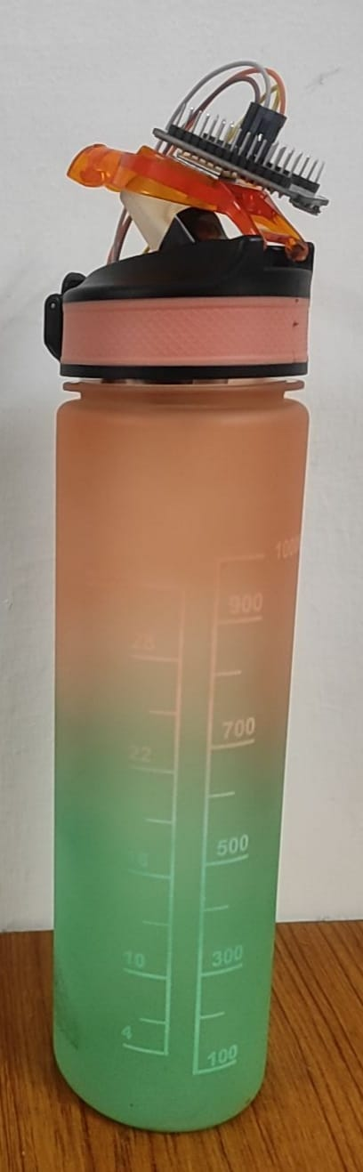

Figure 4.1 Smart Water Bottle

Another study, published in the journal Computers in Human Behavior in 2021, found that smart water bottles (refer figure 4.1) can help people develop sustainable water drinking habits. The study found that people who used a smart water bottle for 12 weeks continued to drink more water even after they stopped using the bottle.

Smart water bottles are still a relatively new product, but they have the potential to be a valuable tool for people who are trying to stay hydrated and improve their overall health. However, there are a few things to keep in mind when choosing a smart water bottle.

We make sure to choose a bottle that is accurate in tracking your water intake. Some smart water bottles have been shown to be more accurate than others. One way to check the accuracy of a smart water bottle is to compare it against a known volume of water. For example, fill a cup with exactly 8 ounces of water and then pour the water into the smart water bottle. We offer additional features such as temperature tracking, hydration reminders, and goal setting.

Finally, we consider our budget. Smart water bottles that use IoT and Arduino are often more affordable than traditional smart water bottles. This is because Arduino is a low-cost platform that can be used to create a variety of electronic devices. Additionally, there are many open-source Arduino projects available online, which can be used to create a smart water bottle without having to purchase expensive components or software.

1. FUTURE WORKS

Exciting prospects for sustainability, user convenience, and health await smart water bottles in the future. Modern connectivity and sensors can track hydration levels and send users' devices real-time data. These bottles may evaluate the surrounding conditions, including humidity and temperature, and suggest the ideal amount of water to drink. Personalization of hydration regimens through integration with wearables and health apps can enhance overall wellbeing.

Sustainable objectives can be furthered by incorporating eco-friendly materials into smart bottles. Given the potential advantages, particularly for the healthcare industry, more research and development is in fact needed for smart water bottles.

You can also keep a quality check sensor, which gives you information about the quality of the water. For patients with medical conditions that necessitate them to monitor their water intake, developing a mobile application is another option. In the event that they exceed the threshold, the relevant notifications can be sent. Cooperation with smart home ecosystems may make voice commands for temperature control or refilling possible.

In conclusion, the future of smart water bottles will combine sustainability, health, and technology to improve how we engage with our surroundings and stay hydrated.

1. CONCLUSION

In conclusion, the AquaTrail project represents a significant step forward in the intersection of technology and health.

Through this project, we have successfully designed, developed, and tested a smart water bottle that not only helps individuals stay hydrated but also promotes healthier lifestyles.

AquaTrail incorporates a range of features, including hydration tracking, personalized reminders, and compatibility with mobile applications, which provide users with the tools they need to make better choices when it comes to their daily water intake.

Our project has highlighted the potential for technology to enhance our well-being and encourage healthier habits in a world where staying hydrated can be challenging.

Smart water bottles that use IoT and Arduino are often more affordable than traditional smart water bottles. This is because Arduino is a low-cost platform that can be used to create a variety of electronic devices. Additionally, there are many open-source Arduino projects available online, which can be used to create a smart water bottle without having to purchase expensive components or software.

Overall, smart water bottles that use IoT and Arduino are a promising technology with the potential to improve people's health and well-being. Here are some specific examples of how these bottles can be used:

Athletes can use smart water bottles to track their hydration levels during workouts and competitions. This can help them to avoid dehydration and improve their performance.

People with diabetes can use smart water bottles to track their fluid intake and ensure that they are drinking enough water. This can help to prevent complications from diabetes, such as kidney disease.

Older adults can use smart water bottles to remind them to drink water throughout the day. This can help to prevent dehydration, which is a common problem among older adults.

People who live in hot climates can use smart water bottles to track their hydration levels and ensure that they are drinking enough water to stay hydrated. This can help to prevent heatstroke and other heat-related illnesses.

REFERENCES

1. Pankajavalli, P. B., R. Saikumar, and R. Maheswaran. "Hydration reminding smart bottle: IoT experimentation." *2017 Innovations in Power and Advanced Computing Technologies (i-PACT)*. IEEE, 2017.
2. Wijanarko, Angga Edwin, Maman Abdurohman, and Aji Gautama Putrada. "A Fuzzy Logic Based Internet of Things (IoT) for Smart Water Bottle." 2019 5th International Conference on Computing Engineering and Design (ICCED). IEEE, 2019.
3. Ravindran, Rahulkrishnan, Radhika Ravindran, and T. Anjali. "HydrationCheck: An IOT based smart water bottle." 2022 13th International Conference on Computing Communication and Networking Technologies (ICCCNT). IEEE, 2022.
4. Perera, Charith, Chi Harold Liu, and Srimal Jayawardena. "The emerging internet of things marketplace from an industrial perspective: A survey." *IEEE transactions on emerging topics in computing* 3.4 (2015): 585-598.
5. Jovanov, Emil, Vindhya R. Nallathimmareddygari, and Jonathan E. Pryor. "SmartStuff: A case study of a smart water bottle." 2016 38th annual international conference of the IEEE engineering in medicine and biology society (EMBC). IEEE, 2016.
6. Cohen, Rachel, Geoff Fernie, and Atena Roshan Fekr. "Monitoring fluid intake by commercially available smart water bottles." Scientific Reports 12.1 (2022): 4402.
7. Tommy, Robin, and Aswahty S. Krishna. "Interactive Water Bottle Application on a Smart Phone to Enhance User Water Consumption." 2017 International Conference on Current Trends in Computer, Electrical, Electronics and Communication (CTCEEC). IEEE, 2017.
8. Baluprithviraj, K. N., et al. "Design and Development of Smart Saline Level Indicator for Healthcare using IoT." 2022 Second International Conference on Artificial Intelligence and Smart Energy (ICAIS). IEEE, 2022.
9. Soubam, Sonia, Manisha Agrawal, and Vinayak Naik. "Using an Arduino and a smartwatch to measure liquid consumed from any container." 2017 9th International Conference on Communication Systems and Networks (COMSNETS). IEEE, 2017.
10. Lee, Nam Eui, et al. "A smart water bottle for new seniors: Internet of Things (IoT) and health care services." International Journal of Bio-Science and Bio-Technology 7.4 (2015): 305-314.
11. Hersent, Olivier, David Boswarthick, and Omar Elloumi. The internet of things: Key applications and protocols. John Wiley & Sons, 2011.
12. Pundir, Parth Sarthi, and Neha Bhadauria. "SMART WATER BOTTLE–A REVIEW." 38
13. Kor, Sumit, Rohit Shinde, Amol Bhosale, and Vijay R. Sonawane. "IOT BASED SMART WATER BOTTLE."
14. Kaner, Gül, et al. "GROW: a smart bottle that uses its surface as an ambient display to motivate daily water intake." Extended Abstracts of the 2018 CHI Conference on Human Factors in Computing Systems. 2018.
15. Jalagam, Laxmi Lahari. "IoT Based Smart Water Bottle." Available at SSRN 3919060 (2021).
16. Vithanage, J., et al. "SmartOne: IoT-based smart platform to manage personal water usage." 2019 International Conference on Advancements in Computing (ICAC). IEEE, 2019.
17. Zhou, Ying, et al. "MossWater: A Living Media Interface for Encouraging Office Workers’ Daily Water Intake." Extended Abstracts of the 2021 CHI Conference on Human Factors in Computing Systems. 2021.
18. Chiu, M. C., Chang, S. P., Chang, Y. C., Chu, H. H., Chen, C. C. H., Hsiao, F. H., & Ko, J. C. (2009, September). Playful bottle: a mobile social persuasion system to motivate healthy water intake. In Proceedings of the 11th international conference on Ubiquitous computing (pp. 185-194).
19. Cabral-Cometa, M., Mendoza, F., Mendoza, M. K., & Estrada, M. (2021). Analysis of the Water Intake and Sedentary Behavior of a Sectarian University Employees. PRINTED IN THE PHILIPPINES ISSN 2599-5456, 26.
20. Mears, Stephen A., and Susan M. Shirreffs. "Assessing hydration status and reported beverage intake in the workplace." American journal of lifestyle medicine 9, no. 2 (2015): 157- 168.
21. Nakamura, Yumi, Hiroshi Watanabe, Aiko Tanaka, Masato Yasui, Jun Nishihira, and Norihito Murayama. "Effect of increased daily water intake and hydration on health in Japanese adults." Nutrients 12, no. 4 (2020): 1191.
22. Spigt, M. G., E. C. Kuijper, C. P. Van Schayck, J. Troost, P. G. Knipschild, V. M. Linssen, and J. A. Knottnerus. "Increasing the daily water intake for the prophylactic treatment of headache: a pilot trial." European journal of neurology 12, no. 9 (2005): 715-718.
23. Wagner, Sandra, Thomas Merkling, Marie Metzger, Lise Bankir, Maurice Laville, Luc Frimat, Christian Combe et al. "Water intake and progression of chronic kidney disease: the CKD-REIN cohort study." Nephrology Dialysis Transplantation 37, no. 4 (2022): 730-739.
24. Andre, Kate, and Matthew Hetrick. "Drink Up: A Smart, Hydration-Focused Water Bottle." (2020).
25. Pushpalatha, N., et al. "A Review on Intelligent Water Bottle Powered by IoT." 2023 9th International Conference on Advanced Computing and Communication Systems (ICACCS). Vol. 1. IEEE, 2023.

2023 International Conference on Networking and Communications (ICNWC) | 979-8-3503-3600-9/23/$31.00 ©2023 IEEE | DOI: 10.1109/ICNWC57852.2023.10127264